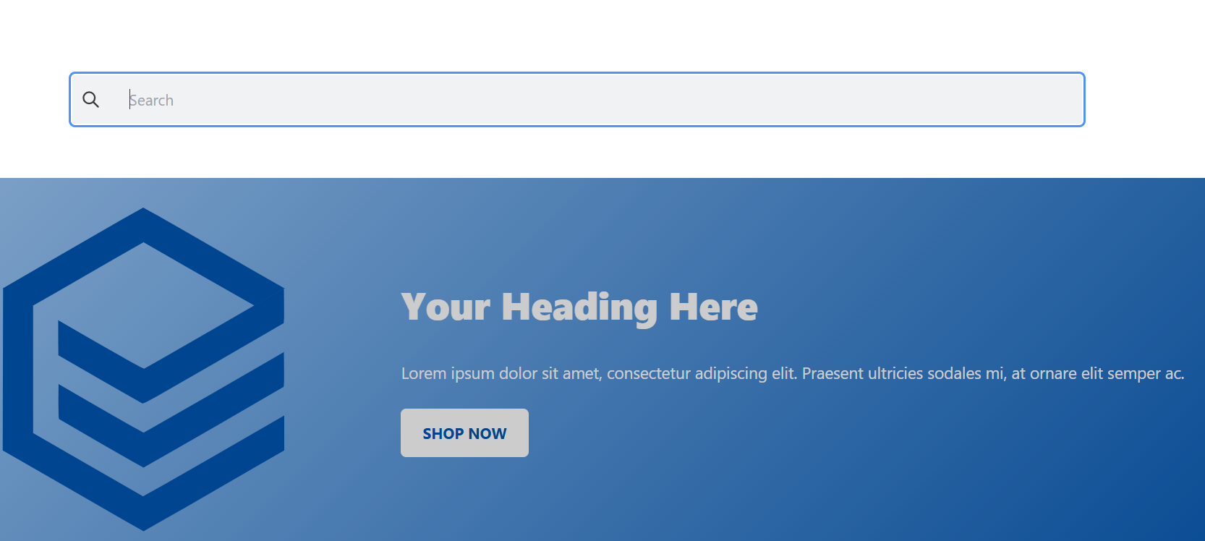

Test Id 6 : Search history is not showing on click in the search bar.